**FIRST PROGRAM**

* Save first1.cc in directory **ns-allinone-3.37/ns-3.37/examples/tutorial/**
* The following commands has to be run to setup ns3 in order to run .cc files after changing the directory.

1. ./ns3 clean : to delete any existing ns3 build
2. ./ns3 configure --build-profile –enable-examples –enable-tests : to configure network simulation
3. ./ns3 build : to build network simulation

**Once build is successful, we can run the .cc programs.**

* **Program Modification *( all the lines modified from first.cc are commented*)**

1. Line 47: Modified data rate as 10 Mbps
2. Line48: Modified delay as 2ms
3. Line56: Modified IP address as 192.168.2.0/24
4. Line 60: Modified port number for UDP server as 63
5. Line 63: Modified port number as 63
6. Line 69: Modified line 69 to update packet size as 256 bytes
7. Line 75: added line to get .pcap file. Name given to pcap file is myfirst1. So the output .pcap file after running first1.cc will be **myfirst1-0-0.pcap** and , **myfirst1-1-0.pcap**

pointToPoint.EnablePcapAll("myfirst1")

1. Once Build is successful; to Run first1.cc; execute the command **cp examples/tutorial/first1.cc scratch/myfirst1.cc**

This will create an executable version of first1.cc in scratch folder with name myfirst1.cc.

1. Now to run ; execute command **./ns3 run scratch/myfirst1.cc.** The output obtained is as shown below.

**Explanation/Conclusion:**

* The network build in first1.cc consists of two nodes N0 and N1 with N0 acting as client node and N1 as server.
* Ip addresses assigned : N0 (Client) 🡪 192.168.2.1 N1(server) 🡪192.168.2.2 ; port 63
* As the start time is 2s for clientApps (Line 72); client N0 will start at 2s and send 256 bytes packet to server’s address.
* As propagation delay is 2ms (Line 48); the Server N1 will receive packet from client at 2.00223s and then send 256 bytes back to client at the same time.
* As propagation delay is 2ms (Line 48); the Client N0 will receive packet from Server at 2.00446s.
* Here we have mentioned the **maximum packet** to be transmitted as **1**. If it was **2**, and with current time interval set as 1.0 seconds, the client N0 would send the next packet at 3s; and N1 would receive the second packet at 3.00223s (as the propagation delay is 2ms). At 3.00223s the server node N1 would send back the packet which would be received by client N0 at 3.00446s.

Packet Trace using tcpdump

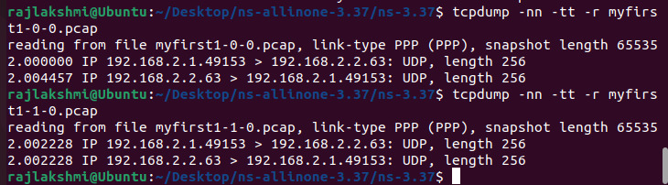

We can see in the dump of myfirst1-0-0.pcap (the client device) that the echo packet is sent at 2 seconds into the simulation. If we look at the second dump (myfirst-1-0.pcap) we can see that packet being received at 2.002228 seconds. We see the packet being echoed back at 2.002228 seconds in the second dump, and finally, we see the packet being received back at the client in the first dump at 2.004457 seconds.